Year 11 Parents’ Evening – Thursday 29th January 2026, 4:30-7pm.
Dear Parent/Carer,
Thank you to those who attended our Year 11 Parents GCSE Support Evening last night. Following this, I would like to invite you to our forthcoming Year 11 Parents’ Evening on Thursday 29th January, from 4:30pm – 7.00pm. This is an in-person event where you will have face-to-face appointments with your child’s individual teachers.
Parents’ Evening is an important opportunity for you to discuss your child’s learning with their subject teachers and find further ways to support your child’s progress through their GCSEs. This is arguably the most important Parents’ Evening of your child’s 5 years with us at Filey Academy. Class teachers in the Core and Ebacc subjects will be able to give you Year 11 trial exam grades and feedback. All subject teachers will give you information about what your child needs to do in order to achieve success in their GCSE. You will receive your child’s current GCSE predictions in their academic progress report on Thursday 29th January.
As of today, Friday 9th January, your child has 68 school days left, in 14 school weeks, before their summative GCSEs begin. Many of our students will have already completed practical elements of their final GCSE by this time. They have 68 school days to make the difference. Please ensure you support your child by encouraging them to have attendance above 95%, encouraging them to attend after school enrichment sessions and by attending our Year 11 Parents’ Evenings.
We will continue to use the MCAS ‘My Child at School’ phone and computer app to book appointments. The MCAS app allows you to choose your face-to-face appointment times with teachers. All appointments will be 7 minutes long. Please note, some members of staff teach multiple Year 11 classes and therefore appointments are allocated on a first-come-first-served basis. Details of how to book are included below in this letter.
The system will be live for booking on Monday 19th January at 17:00 and close on Friday 23rd January at 17:00.
If you have problems accessing this platform, please contact the reception staff at Filey Academy who will be able to assist you in making your appointments.
The academy’s doors will open to families at 4:25 pm for this event. We look forward to welcoming you on 29th January.
Yours faithfully,
Mr J Philliskirk
Associate Vice Principal
Filey Academy

How to book an appointment using the My Child at School App

- Download the My Child at School app from your preferred app store
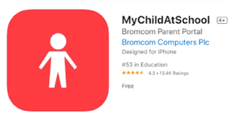

- From the MCAS app, select Parents Evening from the side Menu
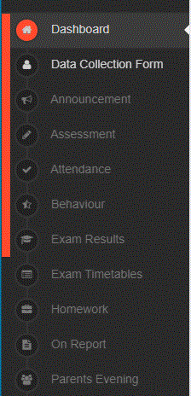

- Choose either the 'Manual' or 'Quick Book' option to book your appointment.
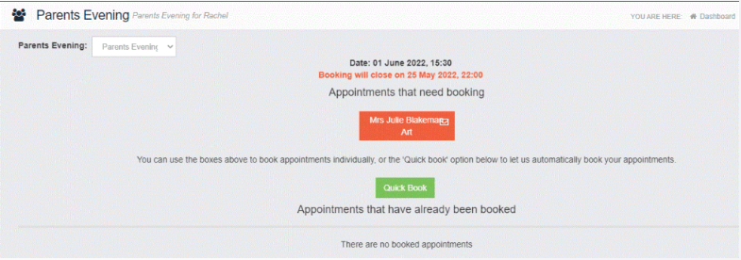

If you choose 'Manual' you will be able to choose your own appointments - This is the recommended option as you will be able to select the times that you would like your appointments.
If you choose 'Quick Book' you will need to tell the system your arrival time and it will automatically book all of the available appointments for you. Please note, using quick book means that the system will automatically allocate your appointments meaning that your appointments may be spread throughout the evening.

